**Capstone Project - The Battle of Neighborhoods (Week 2)**

**Description of the problem**

Bubble tea, which is a popular drink in Asia, attracts more and more customers in European market in recent years. Many Bubble tea brands come to open their stores in France, especially in Paris, which is one of the top touristic destination and receive the visitors around the world each year.

One well-known bubble tea brand wants to enter this potential market in Paris and looks for a good location to set up their shop. The criteria for the decision are:

1. Not far from the center of Paris

2. Not far from famous attractions

3. Having less existing bubble tea shops

We will analyze which neighborhood is the best place for him to open his store.

The audience of this project could be the investor or bubble tea shops owner or anyone who wants to research about this market.

**Description of the data**

First of all, we will search for some popular attractions in Paris and list them down. Then, we will use Foursquare API to extract all the Bubble tea shops in Paris. After that, we will cluster those bubble tea shops according to their GPS coordinates (latitudes and longitudes) by making the attractions as their centroids. At the end, we could suggestion which cluster has the less existing shops and near which attraction.

**Methodology**

Firstly, we list Paris top attractions to a list and convert into pandas data frame. After that, we find the coordinates of that attractions using geocode and add to our data frame.

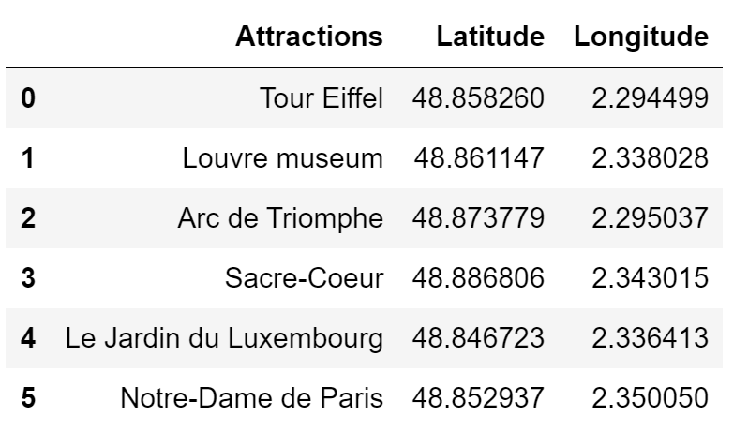

The coordinates of the center of Paris is: latitude =48.864716 and longitude = 2.349014. With these coordinates, we build a folium map to show the locations of top attractions in Paris.

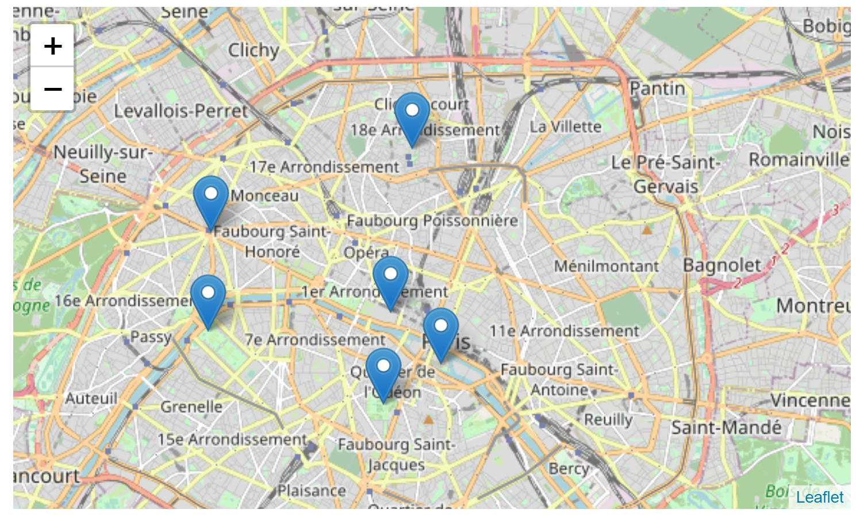

The next step, we determine the central coordinates of those attractions in order to extract all the bubble tea shops in fixed range. By applying the mathematic method, we got the central coordinates: latitude = 48.86327, longitude = 2.326174.

Thank to Foursquare API, we can extract the existing bubble tea shops around the central coordinates. We got 47 bubble tea shops in our search. Here are some examples:

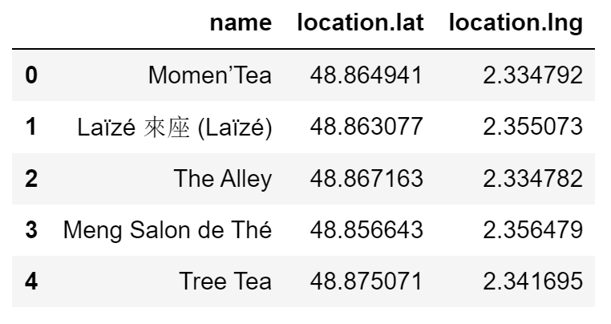

We put these bubble tea shops on our map to illustrate their locations. You can see them in blue spot.

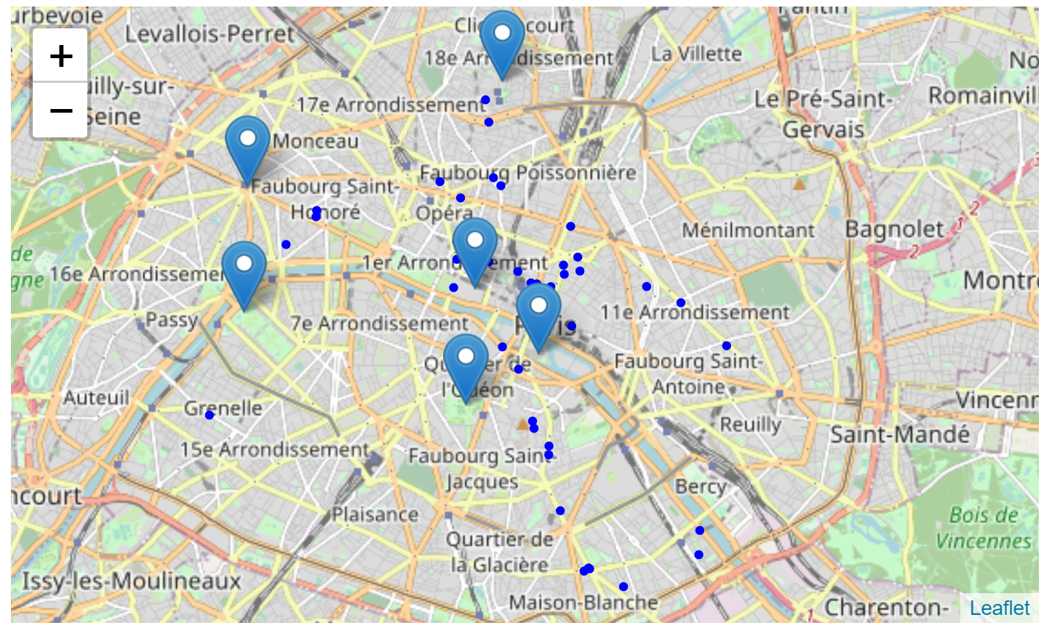

Now we can cluster those shops by making our attractions to be the centroids of the cluster. We got 6 clusters.

**Result**

After analyzing the clusters, we found the results as below:

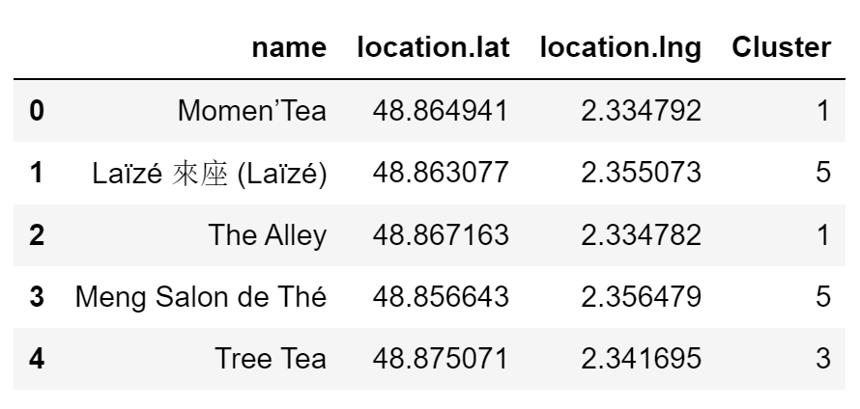

|  |  |  |
| --- | --- | --- |
| Cluster | Color | Number of shops |
| 5 | Orange | 20 |
| 1 | Purple | 14 |
| 3 | Light blue | 5 |
| 4 | Green | 4 |
| 2 | Blue | 3 |
| 0 | Red | 1 |

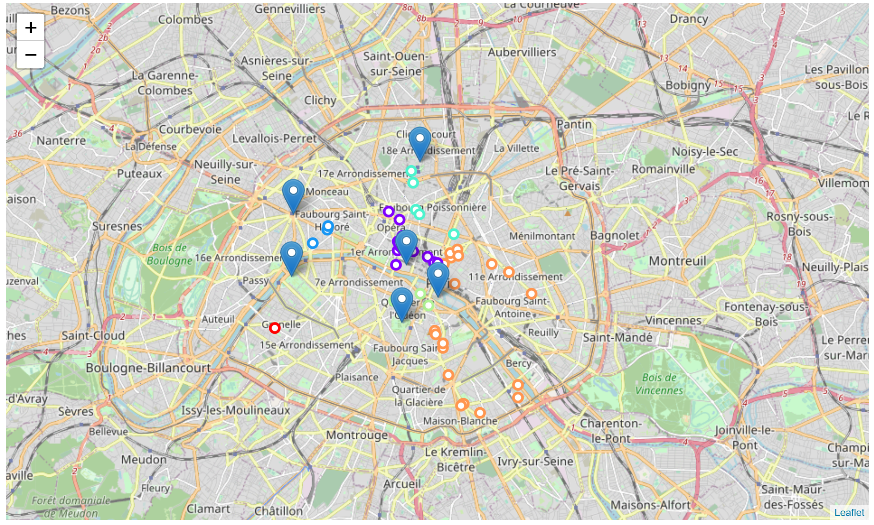

There are 20 bubble tea shops nearby Notre-Dame de Paris (Cluster 5, Orange color).

There are 14 bubble tea shops nearby Louvre Museum (Cluster 1, Purple color).

There are 5 bubble tea shops nearby from Sacre-Coeur (cluster 3, Light Blue color).

There are 4 bubble tea shops nearby Le Jardin du Luxembourg (cluster 4, Green color).

There are 3 bubble tea shops nearby Tour Eiffel and Arc de Triomphe (cluster 3, Blue color).

There are only 1 bubble tea shops far away from any attractions (cluster 2, Red color).).

**Discussion**

According the result above, we could say that there are many bubble tea shops existing in the center of Paris, especially in the locations nearby Notre-Dame de Paris and Louvre Museum. However, there are few bubble tea shop around Arc de Triomphe and Tour Eiffel.

**Conclusion**

In conclusion, the investor should look for the location around Arc de Triomphe or Tour Eiffel. They are both the most famous monuments in Paris and the top destinations in Paris for tourists. In addition, there are still not many bubble tea shop opened yet, so this location should be considered.